
BrailleConnect 12

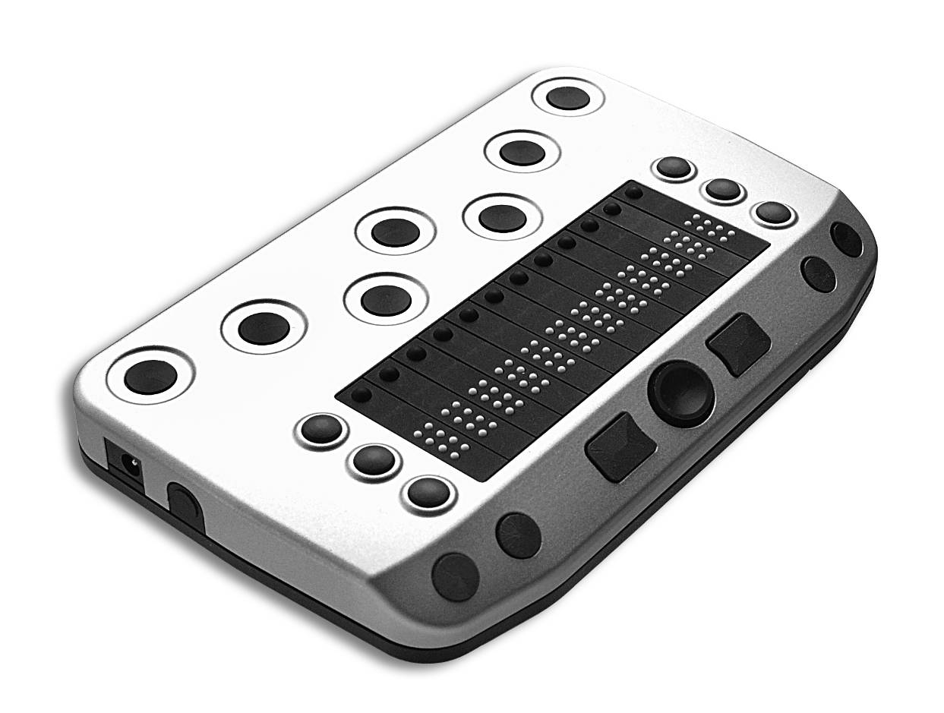
User Manual
V1.0

(c) 2006 Copyright by HumanWare
175 Mason Circle, Concord, CA 94520
800-722-3393 www.humanware.com
e-mail: us.info@humanware.com

All rights reserved. No part of this manual may be reproduced or transmitted in any form or by any means, electronic or mechanical, including photocopying, recording, or information recording and retrieval systems, for any purpose, without the express written permission of HumanWare.

Table of Contents
1 Table of Contents 2
2 Introduction: BrailleConnect 12 3
3 About this manual 4
4 Description of the device 5
4.1 Keys and Functions 5
4.2 AC adapter and battery 6
5 Power on/off, Sleep mode 7
6 The BrailleConnect 12 System Menu 8
6.1 The lines of the basic System Menu and their meaning. 8
6.1.1 First line: name of the braille display 8
6.1.2 Second line: Status 9
6.1.3 Third line: serial number 9
6.1.4 Forth line: Bluetooth name 1
6.2 The advanced System Menu 10
6.2.1 Fifth line: automatic sleep timer 10
6.2.2 Sixth line, automatic sleep timer settings 10
6.2.3 Seventh line : Sound on/off 10
6.2.4 Eighth line: Vibration 11
6.2.5 Nineth Line: dot strength 1
6.2.6 Tenth line: Restore factory settings. 1
6.2.7 Eleventh line: Quit menu and save settings 11
6.3 Self-test 11
6.4 Firmware updates 12
7 Installation and Interface Ports 13
7.1 Interface 13
7.1.1 Bluetooth Interface 13
7.2 BrailleConnect with mobile phone 13
7.2.1 TALKS 14
7.2.2 Mobile Speak 14
7.3 BrailleConnect with PDAs 14
7.3.1 Mobile Speak Pocket 14
7.3.2 Pocket HAL 15
7.4 Connecting to a PC 15
7.4.1 VIRGO 15
7.4.2 JAWS 16
7.4.3 Window-Eyes 16
8 Troubleshooting 17
9 Technical details 18
9.1 BrailleConnect 12 18
10 Contact details 19

Introduction: BrailleConnect 12

Congratulations on buying your new mobile braille display BrailleConnect 12. You have just acquired one of the latest braille displays which offer a new dimension in functionality, flexibility and portability.

BrailleConnect 12 is a new braille display with 12 braille cells and a 6 Dot braille keyboard designed primarily for mobile use together with mobile phones and PDAs. BrailleConnect 12 can also be used as a braille Display for your favourite Screen Reader like VIRGO, Window-Eyes or JAWS. BrailleConnect 12 connects to your mobile device via a wireless Bluetooth interface. Leave your mobile device in your pocket while you control its full functionality with BrailleConnect 12s function keys and joystick.

Outstanding battery life time of more than 20 hours of continuous operation or more than 70 hours in stand by allow total freedom and mobility.

The universal power supply and battery charger that comes with BrailleConnect 12 allows fully charging the device in less than 2.5 hours.

The highly robust casing is made from light metal. Such techniques are found in modern camera bodies and are already used in other HumanWare products. They allow us to construct very elegant, stable and robust equipment.

BrailleConnect is a new milestone in the development of mobile equipment for blind users. It’s outstanding feature is the combination of the most up-to-date technology with a tried-and-tested simple design.

About this manual

The next chapter contains a description of the device and its power supply. There is another chapter about switching the device on and off, as well as how to use the sleep mode for power saving. Then follows general information and the System Menu settings.

The following chapter describes the installation process and gives details on how to connect BrailleConnect 12 to various devices.

Then follows description of specialties under various screen readers.
The screen reader determines which functions are assigned to the braille keys, and thus how BrailleConnect 12 works with such applications.

The last chapter contains hints and tips to help sort out minor errors yourself.

At the end of the manual you will find details of our branches and our Hotline number which you are welcome to ring with questions and suggestions.

We hope you enjoy working with your new braille display.

The HumanWare Group

Description of the device
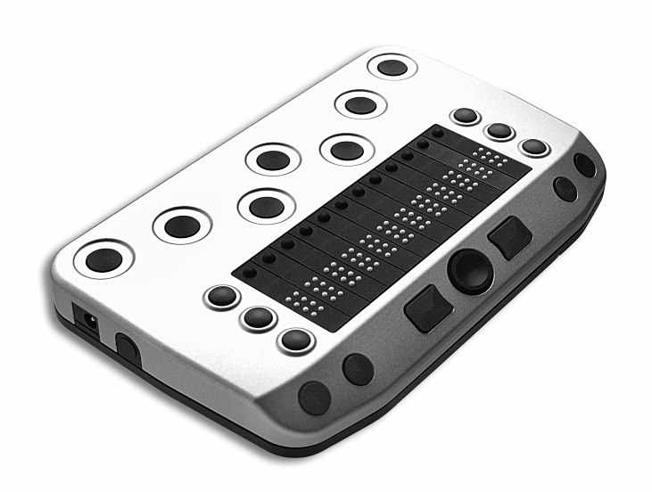

Keys and Functions

At the left side of the case, you will find a round socket for the 5 Volt DC power supply. Use the power supply that comes with BrailleConnect 12 only!

The convex Power button is located just to the right of the power socket, at the left side of BrailleConnect 12. To turn the device on or off, press and hold this button for approximately 2 seconds. BrailleConnect 12 will beep when switched on or off. (A short press on the power button puts BrailleConnect 12 to sleep or wakes it up.)

On the front are the 12 braille cells. Above each cell is a cursor routing key P1 to P12).

On both the left and right of the braille cells are three small round keys, known as Display keys. On the left they are numbered D1 to D3 from top to bottom, and on the right D4 to D6 from top to bottom (i.e. the numbering of the braille dots) and can be pressed individually or in combinations.

Bluetooth, being a wireless connection, has no external plug or connector. The antenna is integrated into the device, there is nothing visible or tangible.

On the front edge there are more function keys. On both the left and right front edge there are two round recessed function keys. From left to right F1 and F2 to the left and F3 and F4 to the right.

In the middle of the front edge there is the joystick which can be moved in four directions up, down, left and right. It can also be pressed in the center.

To the left of the joystick there is one more key B9 and to the right B0. B9 and B0 are often used as space bars for the braille keyboard.

The functions of the keys vary according to the screen reader being used.

Behind the braille cells you will find the 6 dot braille keyboard. The keys are located ergonomically, so that your fingers will rest in a comfortable position on dots 1 to 6.

There is one extra key on this keyboard. Between braille dots 1 and 4 you will find one more key, B11. This usually functions as an additional space bar. The reason is quite simple. If you have BrailleConnect resting on a table, you will enter braille just as usual by pressing dots 1 to 6 and the space bars B9 and/or B0. However, if you hold BrailleConnect 12 in your hands, your thumbs rest under the device holding it. So now, you can enter a space character by simply pressing B11 with one of your index fingers.

Please fully charge your braille display before the first use. A full charge requires about 2.5 hours.

AC adapter and battery

BrailleConnect 12 has a built in rechargeable Lithium Ion battery. Please charge the device with the power supply that comes with it.

Thanks to our unique battery management technology, BrailleConnect is ready for 20 hours of continuous operation or more than 70 hours in stand by. The automatic sleep timer helps you save energy.

For charging the battery insert the adapter’s small plug into the left hand socket on BrailleConnect and then plug the adapter into a AC outlet. Please use only the original AC adapter.

BrailleConnect 12 beeps when connected to power. While charging the braille display shows “charging” and “charge done” when the battery is fully charged.

After about 2.5 hours BrailleConnect 12 is fully charged. You can also use BrailleConnect 12 while charging.

You can inform yourself about the battery status in the system menu (see chapter 6)

We recommend you fully charge the battery before first use of BrailleConnect.

BrailleConnects battery management includes a battery protection circuitry that prevents it from being damaged by total discharge. If the battery is low, BrailleConnect will warn you by beeping (If sounds are on in the system menu) before it will switch off automatically. If you cannot charge the battery now, you should be prepared for the device automatically switching off in a few minutes.

Please never try to replace the battery yourself. This will likely damage the device and warranty will be lost. In case of repair please address your local dealer orHumanWare.

Power on/off, Sleep mode

BrailleConnect 12s power button is much more than a simple on/off switch. It also controls the power saving sleep mode by putting BrailleConnect 12 to sleep or waking it up again.

Once switched on, BrailleConnect 12 is ready for 20 hours of continuous operation.

In sleep mode BrailleConnect 12 can live about 70 hours in stand by. In sleep mode, power is removed from the braille cells, however the Bluetooth connection to the mobile device is kept alive. There is no data transfer between both devices. As soon as the mobile device sends data to BrailleConnect 12, it will wake up immediately. A short press on the power button will also wake up BrailleConnect 12. So there is no need to re-establish a bluetooth connection, BrailleConnect is immediately ready for use.

The following three power states can be reached:

BrailleConnect 12 is on:

- Pressing the power button for more than two seconds switches BrailleConnect off. It beeps when switched off.
- Pressing the power button shortly for less than one second puts BrailleConnect into sleep mode. It will stay ready to receive data, Bluetooth connection is kept alive, power is removed from braille cells.

BrailleConnect 12 is sleeping:

- Pressing the power button for more than 2 seconds will switch BrailleConnect off. It beeps when switched off.
- Pressing the power button shortly for less than one second will wake up BrailleConnect 12. It is ready for use immediately, power is applied to braille cells.
- Receiving data from the mobile device (eg. Phone rings) will immediately wake up BrailleConnect 12.

BrailleConnect 12 is off:

- Pressing the power button for more than 2 seconds switches BrailleConnect 12 on. You can establish a Bluetooth connection to your mobile device now and then use BrailleConnect 12. It beeps when switched on.
- Pressing the power button shortly for less than one second has no effect.

Note: After more than 10 hours of inactivity where no data is transmitted to BrailleConnect 12 and no key has been pressed, it will power off automatically.

The BrailleConnect 12 System Menu

As soon as BrailleConnect 12 receives power the first lines of the System Menu appear on the braille cells. This menu contains information relating to the braille display. This information includes device name, serial number, battery status etc.
If necessary, the settings can be changed on the advanced System Menu. The settings you can change include sounds and sleep timer.

Usually you will pay no attention to the System Menu, as it disappears as soon as data are transferred from your mobile device to the braille display.

The basic System Menu consists of four lines giving the name of the device, battery status, firmware version number, its serial number and Bluetooth name.

It will sometimes be necessary to change display settings, which must be done on the advanced System Menu which can be accessed directly with its own key combination.

The lines in the System Menu can be accessed upwards with D1 (top left), and downwards with D3 (bottom left). Whenever the System Menu is called up the first line will be displayed.

Items can be selected in the advanced System Menu by pressing one of the cursor routing keys above the display. The active or selected item is indicated with braille dots 7 and 8.

The lines of the System Menu will be described below.

To quit the advanced menu, browse through to the “Menu off” option and press a cursor routing/position key over the word “off”; this is done automatically as soon as data has been exchanged between the PC and the braille display.

All settings are automatically saved when quitting the System Menu and remain active until otherwise changed.

The lines of the basic System Menu and their meaning.

Note:
If reading this document as an RTF file on the PC, the BlackBrl.ttf font must be installed from the accompanying installation CD so that the braille version of the menu can be seen, otherwise only cryptic symbols will appear. As each line is also written in text, this is not strictly necessary.

First line: name of the braille display
This is the first entry in the System Menu. It displays the name of the braille display in Grade II.

Brl 3nect (BrailleConnect)


Second line: Status
This line shows battery status (charging percentage) and the version number of the firmware.

Status: bb% ver.xx



bb = charging percentage.
Vxx = Firmware-Version

Third line: serial number
This shows the serial number of the braille display

SN: xxxxxxxx.

  

Forth line: Bluetooth name
This line shows the Bluetooth name which is used to identify BrailleConnect on mobile devices.

BN: xxxxxxxx.

  

The advanced System Menu

The additional options in the advanced system menu allow you to optimise the set-up of your braille display. You can change the sleep timer settings, sound, and braille dot strength, or restore the factory settings.

All settings are saved as soon as you quit the System Menu.

All current and selected settings are indicated by braille dots 7 and 8 underneath the relevant value.

To select, simply press one of the cursor routing keys above the relevant value.

Open the advanced System Menu by first pressing both outer cursor routing/position keys, and then both upper display keys (P1, P12, D1, D4). Hold all four keys for at least 5 seconds or until the device beeps.

The menu will open at the first entry “BrailleConnect”; use D1 and D3 to browse through the menu options.

Fifth line: automatic sleep timer
In this line, you can decide whether BrailleConnect shall automatically go to sleep after a certain time of inactivity. Inactivity means no data is transferred and no key is pressed.

AST: On Off

    

Sixth line, automatic sleep timer settings
Set the length of time after which the braille display will sleep automatically, when no more data is to be transferred and no keys pressed. Press the cursor routing key above the plus or minus sign to increase or decrease the value between one and 60 minutes. This line is only visible if AST ist switched on in the line above.

AST – xx +

    

Seventh line : Sound on/off
Here the sounds can be switched on or off.

Sound: on off



Eighth line: Vibration
On an incoming call, or alarm, BrailleConnect can vibrate. Switch this feature on or off here by pressing a cursor routing above the word “on” or “off”.

VA: on off

 □ □  

Nineth Line: dot strength
The strength with which the pins in the braille cells are set can be amended here, i.e. set them to feel hard and sharp, or soft and round.

DotSt: 1 2 3



Tenth line: Restore factory settings.
This option allows the braille display settings to be restored to their status at the time of delivery. Click on one of the cursor routing/position keys above a word.

Factory sett



Eleventh line: Quit menu and save settings
Press one of the cursor routing keys above the word “off”. When quitting the menu all changes will be saved automatically, and the braille display will resume its normal user status.
Menu off


Self-test

The Self-test function can only be accessed from the advanced System Menu.

In the System Menu, press the first two and the last two cursor routing/position keys on the braille display (P1 P2 P11 P12) together to launch Self-test. The dots of each braille cell will be activated one after the other and then cleared; the pressed keys will also be displayed. As soon as data have been transferred to the braille display the Self-test will end and the display will return to normal.

Once Self-test has been launched, dot B1 then B2, B3, B7, B4, B5, etc. will be set on each cell until all 8 dots are set. They will then be cleared one by one until all are cleared. This process is then repeated.
Press and hold the keys as follows:

D1 to set dots B2B5 in the first cell
D2 to set dots B3B6 in the first cell
D3 to set dots B7B8 in the first cell
D4 to set dots B2B5 in the last cell
D5 to set dots B3B6 in the last cell
D6 to set dots B7B8 in the last cell

Pressing a cursor routing key sets B1B4 in the braille cell underneath.

Firmware updates

So that you can prepare yourself for the future and always acquire the latest BrailleConnect 12 developments, it is possible to update the braille display’s software. All you have to do is to connect the braille display to the PC via Bluetooth and the update program will automatically bring the display up-to-date. This program is so designed that the braille display can still be used and a new update attempted should an update fail.

The update can be launched via a Bluetooth connection.

During a software update the braille display beeps every second and a status bar appears on the braille cells.

If there is an update available, you can download it together with the installation program from the HumanWare homepage www.humanware.com

Installation and Interface Ports

Interface

BrailleConnect communicates via its built in wireless Bluetooth interface with mobile phones (Symbian operating system) that run TALKS or Mobile Speak. It can also be used as a braille display and keyboard for PDAs running Windows CE and the screen readers Mobile Speak Pocket or Pocket HAL. Furthermore, BrailleConnect 12 is also supported by PC screen readers like VIRGO and JAWS. We recommend Windows XP Service Pack 2.

Bluetooth Interface

Bluetooth is a wireless connection. Similar to USB, Bluetooth simulates a virtual Com port.

The wireless technology together with long battery life provided by BrailleConnect 12 allow total freedom and independence from wires within the range of a Bluetooth connection.

Bluetooth is now a common interface for mobile phones, PDAs and Notebook PCs. PCs can be upgraded with Bluetooth using a so-called Bluetooth USB Dongle which installs automatically on Windows XP Service Pack 2 when plugged in.

The first time two Bluetooth devices are connected, they have to be „paired“. This is for security reasons. The devices exchange a PIN code. Later, the devices will regognise each other as being paired automatically, if allowed by the user.

In the Bluetooth environment of a PC you will find BrailleConnect 12 as:

BrailleConnect (xxxxxxx) where xxxxxxxx is the serial number.

The Bluetooth PIN which must be sent to the BrailleConnect 12 is „1234“.

The Bluetooth device class is „Display“.

The devices are identified by different serial numbers, so you can use as many as you like within the same room.

BrailleConnect with a mobile phone

BrailleConnect functions as braille display and braille Keyboard for Symbian mobile phones running TALKS or Mobile Speak.

TALKS

Symbian Series 60 mobile phones with TALKS version 2.x or 3.x, which support a braille display, can use our driver TBI (TALKS braille Interface).

A list of supported phones can be found at the TALKS website:

www.nuance.com/talks

The latest version of TBI can be downloaded from

http://www.baum.de/de/support/downloads.php

this file also includes the TBI installation documentation.

You can of course buy TALKS and TBI from BAUM directly.

Mobile Speak

Symbian Series 60 mobile phones with Mobile Speak can be used with BrailleConnect 12. The driver comes with Mobile speak.

A list of supported phones can be found at the Mobile Speak website:

www.codefactory.es

you can also buy mobile speak from HumanWare directly.

Please read the Mobile Speak manual to find out how to connect Mobile Speak and BrailleConnect 12.

BrailleConnect with PDAs

BrailleConnect 12 functions as a braille display and keyboard for PDAS running Windows CE. Variants like Pocket PC 2003 or Windows mobile are also supported. Possible Screen Readers are Mobile Speak Pocket and Pocket HAL.

Mobile Speak Pocket

PDAs with Mobile Speak Pocket support BrailleConnect 12. The driver comes with the latest version of Mobile Speak Pocket.

A list of supported PDAs can be found at the Mobile Speak website:

www.codefactory.es

you can also buy mobile speak pocket from HumanWare directly.

Please read the Mobile Speak Pocket manual to find out how to connect Mobile Speak Pocket and BrailleConnect 12.

Pocket HAL

PDAs running Pocket HAL support BrailleConnect 12. The driver comes with the latest version of Pocket HAL.

A list of supported PDAs can be found at the Dolphin Pocket HAL website:

www.dolphinuk.co.uk

Please read the Pocket HAL manual to find out how to connect Pocket HAL and BrailleConnect 12.

Connecting to a PC

BrailleConnect can be used as a braille display and keyboard with popular PC screen readers like JAWS, Window-Eyes and VIRGO. Even though having only 12 braille cells may be a limitation a braille display may be useful in many situation e.g. together with a Notebook. The PC or Notebook must provide a wireless Bluetooth interface either built in or using a USB Bluetooth dongle. We recommend Windows XP Service Pack 2, as this automatically detects and installs Bluetooth hardware.

How to find out which virtual serial port is provided by a Bluetooth interface:

- Open Control Panel (Start/settings/Control Panel)
- Select “System” from the list
- In the Window now opening, select the tab “Hardware”
- On this tab, click on “device manager”
- In the device managers tree view, open the branch “Ports (Com and LPT)”
- Search for something similar to “standard serial over Bluetooth port (Com 13)”. There may be more of these. Note down the number after the COM.
- This number is the number of the virtual com port, the device is connected to. The screen reader wants to know this port.

Some screen readers do not support higher numbers of Com Ports. In that case you may want to change the port number. Do this by selecting the “Port (Com and LPT)” branch in device manager like we did above and right click on the Port you want to change (Shift F10 will do the same). The context menu opens and you can click on “Properties”. Then click on the tab “Port settings” and click on the “advanced” button. In the Window now opening there is a List Box “Com Port Number” where you can choose a free port number. Numbers not available will be marked.

VIRGO

Virgo 4.6 and later versions provide for direct operation of the braille display and keyboard.

Open the Virgo menu, select braille/braille display (or braille options/braille display) and then select ‘BrailleConnect 12’ . From the dropdown list headed “Connection:” select the serial port in current usage (Bluetooth will be addressed as virtual serial port)

Find the latest Information about VIRGO at: www.virgo4.de

JAWS

There is a JAWS driver on the BrailleConnect 12 installation CD. The latest version can be downloaded from www.HumanWare.com

This driver supports both braille display output and keyboard input. Installation instructions are included in the driver package.

Window-Eyes

When this manual was printed, the driver was not ready yet. Please find the latest version of Window-Eyes at: www.gwmicro.com

Troubleshooting

Minor things can happen which visibly affect the performance of a braille display but which cannot be called a “real” malfunction. A few examples and hints are described below.

1. The braille display shows no characters.
Check that the device is switched on.
Has a program been launched which is accessing the braille display’s port?
Was the correct port selected when the screen reader was loaded?

2. After switching on there is no reaction from the display either when the System Menu is called up or a computer application is launched.
Battery may be discharged, charge device and try again.
If BrailleConnect does not react, turn off and wait 2 minutes before you switch it on again. If the System Menu is still not displayed or the pins flicker quickly, please contact the HumanWare Service department.

4. BrailleConnect is switched on and the display suddenly stops reacting.
You have not used the display for longer than the automatic sleep time or auto-power-off time limit. Move the cursor or quickly press and release the power button to ‘wake up’ the display.

Technical details

BrailleConnect 12
Mobile 12-cell braille display with braille input keyboard for universal connection
To mobile phones running Symbian and TALKS or Mobile Speak, PDAs running Windows CE and Mobile Speak Pocket or Pocket HAL or Notebooks running Windows XP Service Pack 2 and screen readers like JAWS, Window-Eyes or VIRGO.

Dimensions: 130 x 17 x 81mm (width x height x depth)
Weight: 200g
Function keys: three keys on both the left and right of the braille display,
Two function keys on both left and right side on front. Six braille Input keys, three ergonomically positioned space buttons, one Joystick. One cursor routing key above each braille cell.
Ports: Bluetooth wireless connection
Screen Readers: depending on mobile device: TALKS, Mobile Speak, Mobile Speak Pocket, Pocket HAL, VIRGO, JAWS, et al.
Power supply: built in rechargeable Lithium Ion battery
Battery life: approx. 20 hours of continuous operation, 70 hours stand by in sleep mode.
Charge time: 2.5 hours using charger that comes with the device.

Declaration of conformity / compliance
CE – see appendix.

Contact details

Baum Retec AG,
Schloss Langenzell,
68257 Wiesenbach,
Germany.

Tel. +49 (0) 6223 / 4909 - 0

Email support@baum.de
Website www.baum.de

Subject to alterations
Information supplied without liability
Copyright August 2006 Baum Retec AG

© 2006 Copyright by
BAUM Retec AG
Schloss Langenzell, 69257 Wiesenbach, Germany

All rights reserved. No part of this manual may be reproduced or transmitted in any form or by any means, electronic or mechanical, including photocopying, recording, or information recording and retrieval systems, for any purpose, without the express written permission of Baum Retec AG.



